Experiment – 6: Data Visualization Using Power BI
AIM:
To visualize and analyze business sales data using Power BI by creating interactive dashboards consisting of various charts and graphs.
Dataset Used:
Superstore Sales Dataset
(Contains columns: Row ID, Order ID, Order Date, Ship Date, Ship Mode, Customer Details, Product Details, Sales, Quantity, Discount, Profit, etc.)
PROCEDURE:
1) Importing Dataset into PowerBI desktop
Steps:
- Open Power BI Desktop.
- Click on “Get Data → Text/CSV” (or Excel, depending on your file).
- Browse and select the downloaded Superstore dataset.
- Click Load to bring the data into Power BI.

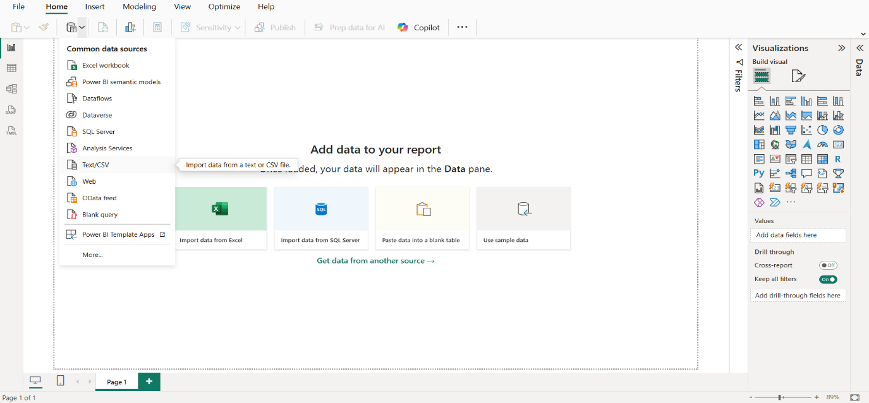
2) Previewing and Loading dataset into Power BI
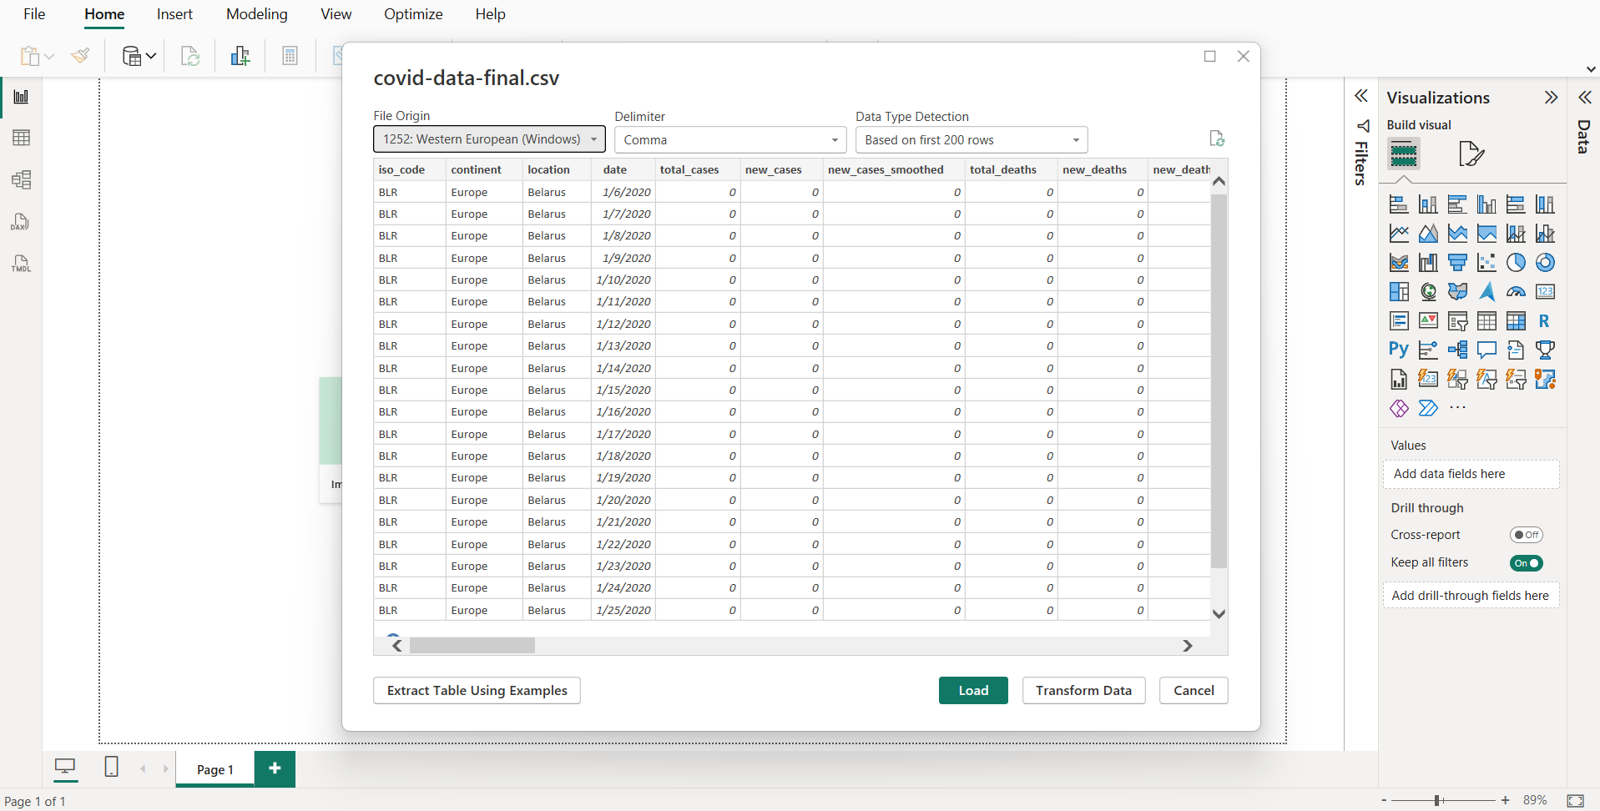
3) Transforming data to clean dataset with the help of Power Query Editor
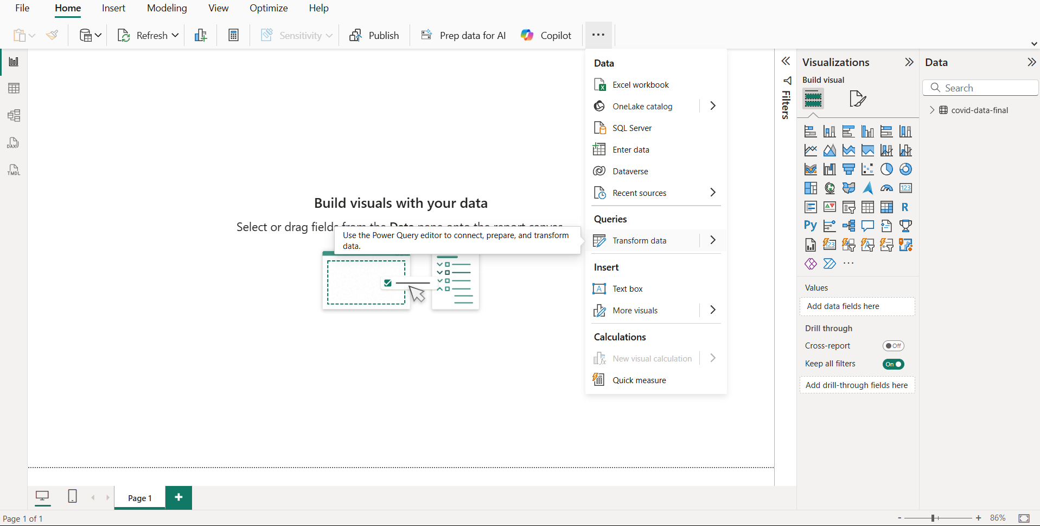

4) Key Performance Indicators (Cards)
(Card Visuals — Total Sales, Total Profit, Total Orders, Total Quantity)
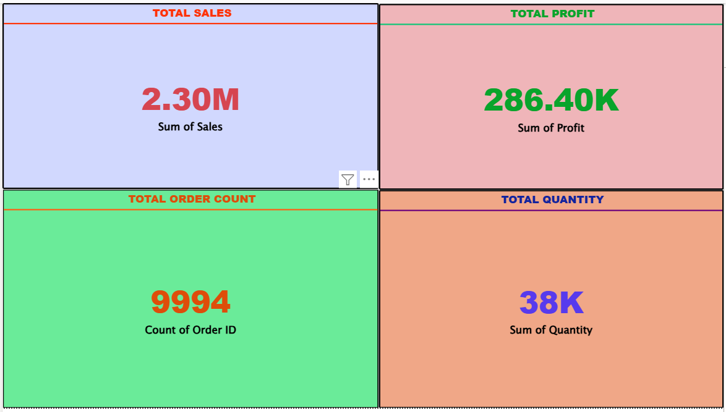
5) Sales and Profit Trend Over Time
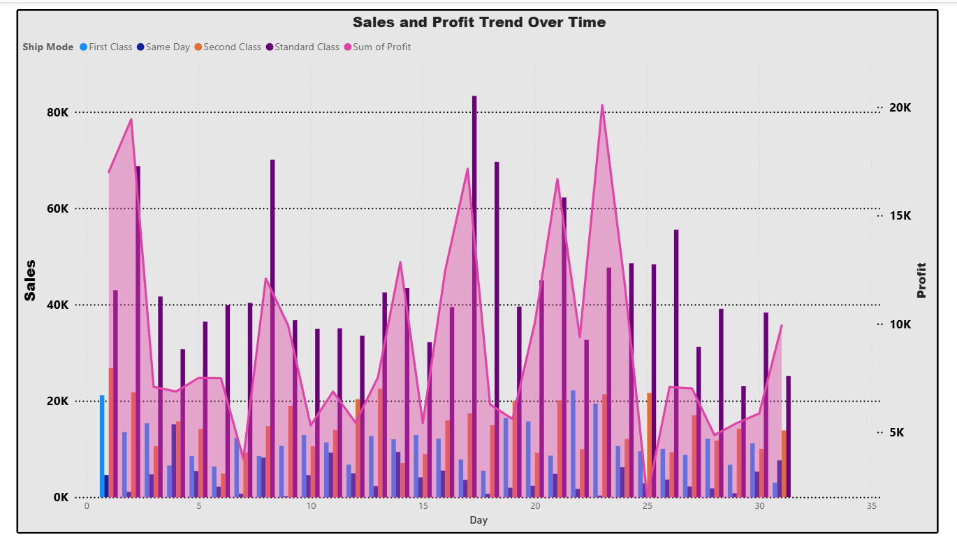
6) Sales by State
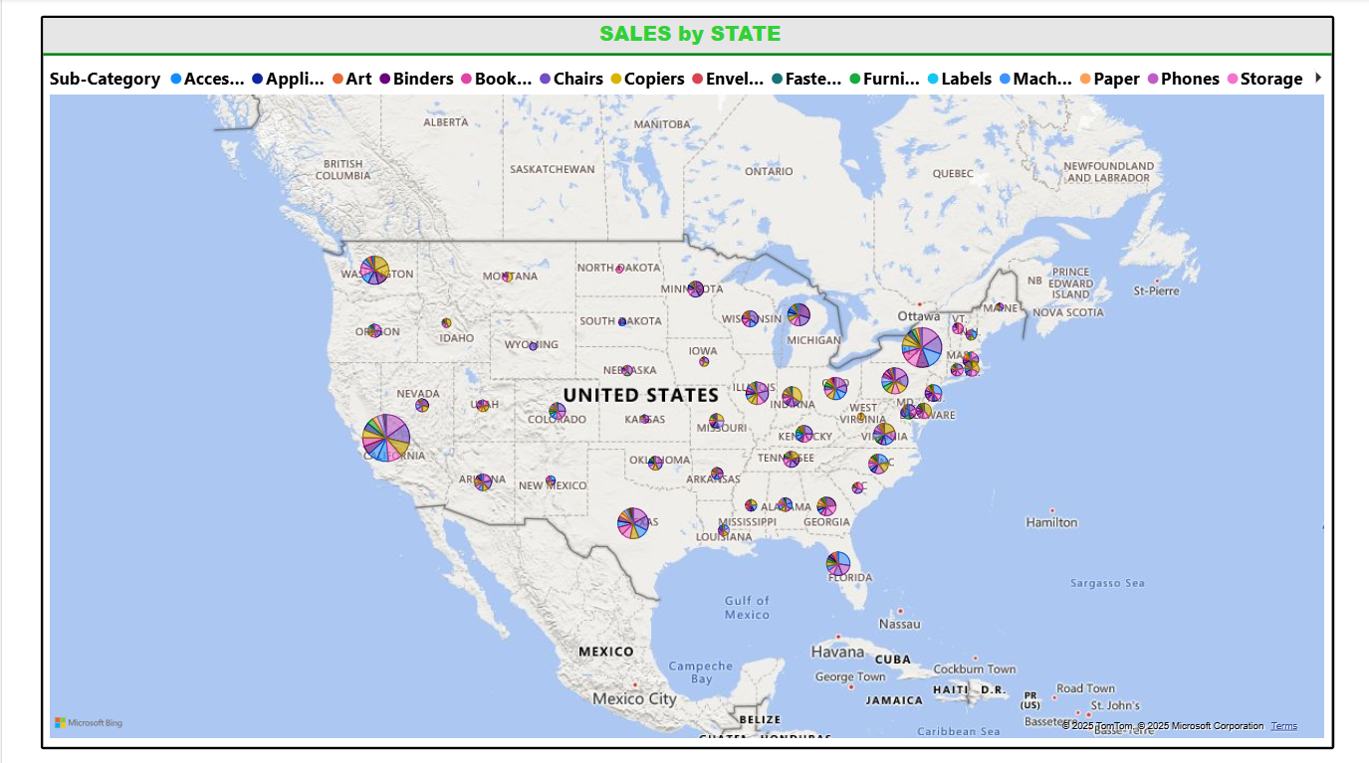
7) Profit Distribution by Region
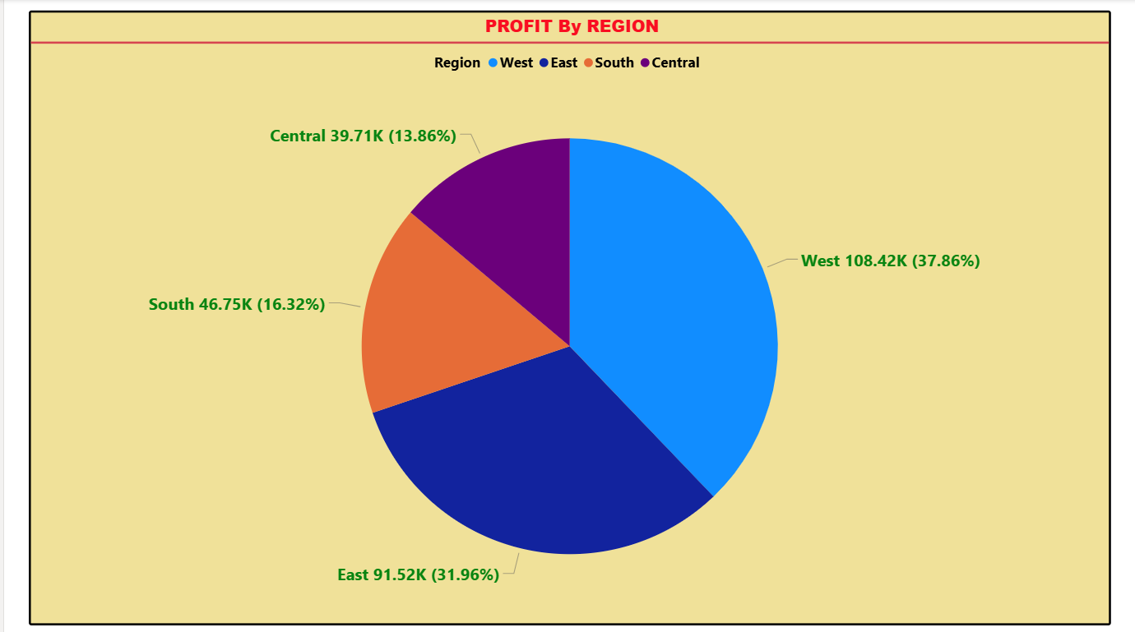

8) Sales by Segment and Category
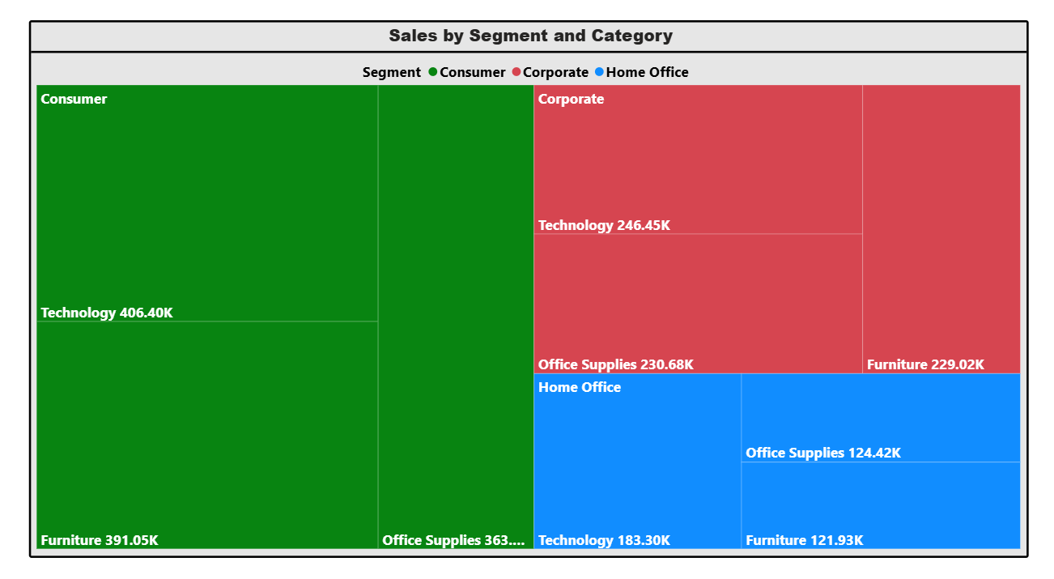
RESULT:-
All the required visuals were successfully created and combined into a single interactive Power BI Dashboard. The dashboard provides a comprehensive and clear view of sales performance, profit trends, and regional insights.

